**Trap Door Package Doc**

*Trap Door Script*

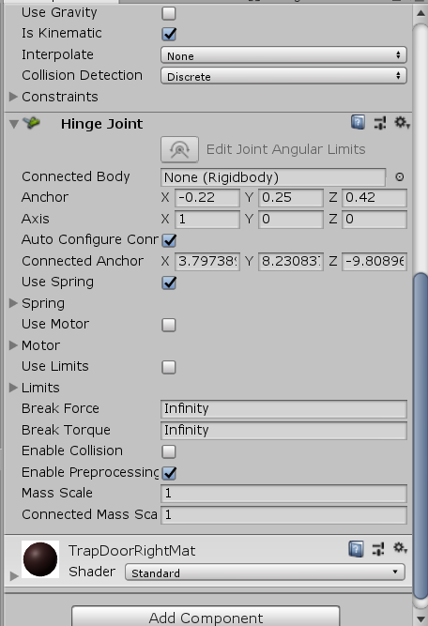

Add component > Hinge Joint

To get the natural effect the trap door. We also could animate it, but this will bring a natural effect.

